**Sir Syed CASE Institute of Technology**



Lab # 6

**ICT lab**

Submitted by: **Abdullah**

Roll No. : **2430-0067**

Class Section: **BSAI**

“On my honor, as student of Sir Syed CASE Institute Islamabad, I have neither given nor received unauthorized assistance on this academic work.”

Submitted to:

**Sir Tayyab Zaman**

DATE : 7/11/2024

**Task 1 :**

Simply drag and drop shapes on canvas and insert text on it by double click on it and cursor will blink to add text in the shape . Now add textboxes where you want and enter text in it . Then add arrow simply drag and drop and another shortcut is left click on the bottom of the shape an drag down the arrow will simply draw and adjust length according to you .

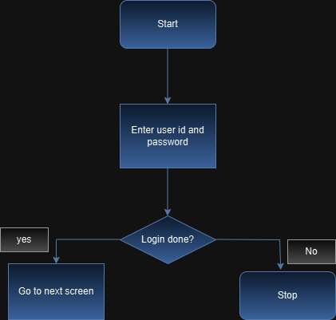

**Task 2 :** Simple add all shapes same as first task .

